Course Three

Go Beyond the Numbers: Translate Data into Insights


Instructions
Use this PACE strategy document to record decisions and reflections as you work through this end-of-course project. You can use this document as a guide to consider your responses and reflections at different stages of the data analytical process. Additionally, the PACE strategy documents can be used as a resource when working on future projects.

Course Project Recap
Regardless of which track you have chosen to complete, your goals for this project are:
- Complete the questions in the Course 3 PACE strategy document
- Answer the questions in the Jupyter notebook project file
- Clean your data, perform exploratory data analysis (EDA)
- Create data visualizations
- Create an executive summary to share your results

Relevant Interview Questions
Completing the end-of-course project will help you respond to these types of questions that are often asked during the interview process:
- How would you explain the difference between qualitative and quantitative data sources?
- Describe the difference between structured and unstructured data.
- Why is it important to do exploratory data analysis?
- How would you perform EDA on a given dataset?
- How do you create or alter a visualization based on different audiences?
- How do you avoid bias and ensure accessibility in a data visualization?
- How does data visualization inform your EDA?
Reference Guide
This project has six tasks; the visual below identifies how the stages of PACE are incorporated across those tasks.
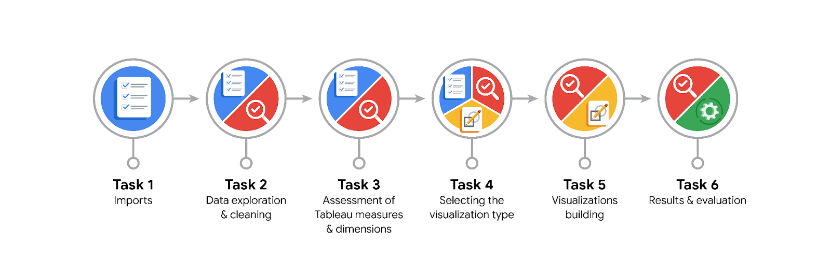
Data Project Questions & Considerations

PACE: Plan Stage
- What are the data columns and variables and which ones are most relevant to your deliverable?
Most important variables are: label (churned or retained), driven_km_drives, duration_minutes_drives, activity_days, driving_days

- What units are your variables in?
Time variables are in minutes. Having them in hours may be more useful.
Distance variables are in km.

- What are your initial presumptions about the data that can inform your EDA, knowing you will need to confirm or deny with your future findings?
Based on the previous data understanding phase, it looks like those who churned are actually pro drivers, as they have less driving days but with significantly higher displacements and driving times per drive.

- Is there any missing or incomplete data?
There are 700 missing entries in the label variable.

- Are all pieces of this dataset in the same format?
Distances are in float. Times are in minutes.

- Which EDA practices will be required to begin this project?
Since we’ve already discovered the data, we shall begin with cleaning to handle missing values, and possible outliers.

PACE: Analyze Stage
- What steps need to be taken to perform EDA in the most effective way to achieve the project goal?
Then we will iteratively perform validating as well as visualizations as deliverables.

- Do you need to add more data using the EDA practice of joining? What type of structuring needs to be done to this dataset, such as filtering, sorting, etc.?
Looks like we have a good amount of data to discover insights. Some qualitative variables should be transformed to `category` dtype. Also driving duration may be more insightful if presented in hours.

- What initial assumptions do you have about the types of visualizations that might best be suited for the intended audience?
- Bar plots to compare certain parameters between different labeled users.
- Boxplot to study distribution of `drives`.
- Scatter plot to find the trend on `derives` vs. `sessions` among different labels.

PACE: Construct Stage
- What data visualizations, machine learning algorithms, or other data outputs will need to be built in order to complete the project goals?
Using boxplots would be beneficial to identify outliers and their intensities. This is also useful beside histograms to analyze and compare median and overall distribution.
Each diagram can also be divided into `churned` and `retained` labels to investigate if there are meaningful discrepancies between the two.
Then outliers can be imputed by 95th percentile for future uses of ML models.

- What processes need to be performed in order to build the necessary data visualizations?
First, questions and curiosities in mind trigger thinking of a certain visualization to compare trends and distributions. Then once the data is cleaned and well structured, a related visualization can be applied.

- Which variables are most applicable for the visualizations in this data project?
Those related to app usages, driving sessions, driving mileage and time, and devices.

- Going back to the Plan stage, how do you plan to deal with the missing data (if any)?
We better leave them as they are for EDA, since they’re not mistakes or critical ones.

PACE: Execute Stage
- What key insights emerged from your EDA and visualizations(s)?
1. Device type has no effect on churn rate.
2. Significantly more driving with significantly less driving days are associated with churned users.

- What business and/or organizational recommendations do you propose based on the visualization(s) built?
Since churned users are the ones who look to be professional or business-related drivers, their activities and intentions need to be investigated for better Waze service, motivating them to stick to Waze.

- Given what you know about the data and the visualizations you were using, what other questions could you research for the team?
- Data-related questions need to be asked from the data team regarding 2nd insight.
- It should also be investigated by the data team why more than 40 % of app usages are done in the last month, despite sign ups having been done years ago!
- Reasons why drives_avg_speed_kmph is extremely heavily tailed above 300 kmph!

- How might you share these visualizations with different audiences?
Those visualizations giving away overall insights would be beneficial for decision maker stakeholders, whereas the ones which raise critical questions regarding the data and patterns therein, need to address data professionals.

